CARRIOR MOTORS

*User Guide*

|  |  |  |
| --- | --- | --- |
| Supervisor. | MISS HAIQA | |
| Batch. | 2207G1 | |
| Group. | A | |
| Serial No. | Enrollment Number | Student Name |
| 1. | 1391313 | M.SOALEH |
| 2. | 1392204 | ALIZA REHAN |
| 3. | 1392254 | ALIZA SHAHID |
| 4. | 1392200 | MUHAMMAD HUZAIFA |
| 5. | 1387471 | SUFIYAN SIRAJ |
| 6. | 1391708 | M.RAMIZ ZAKIR |

# CARRIO MOTORS CARS



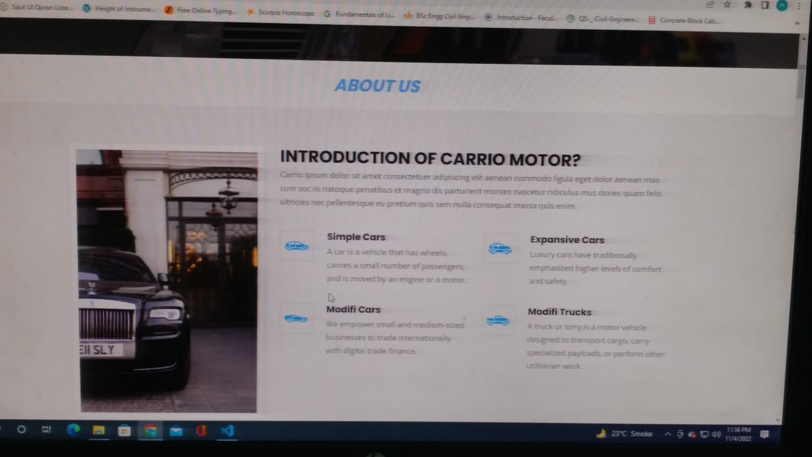

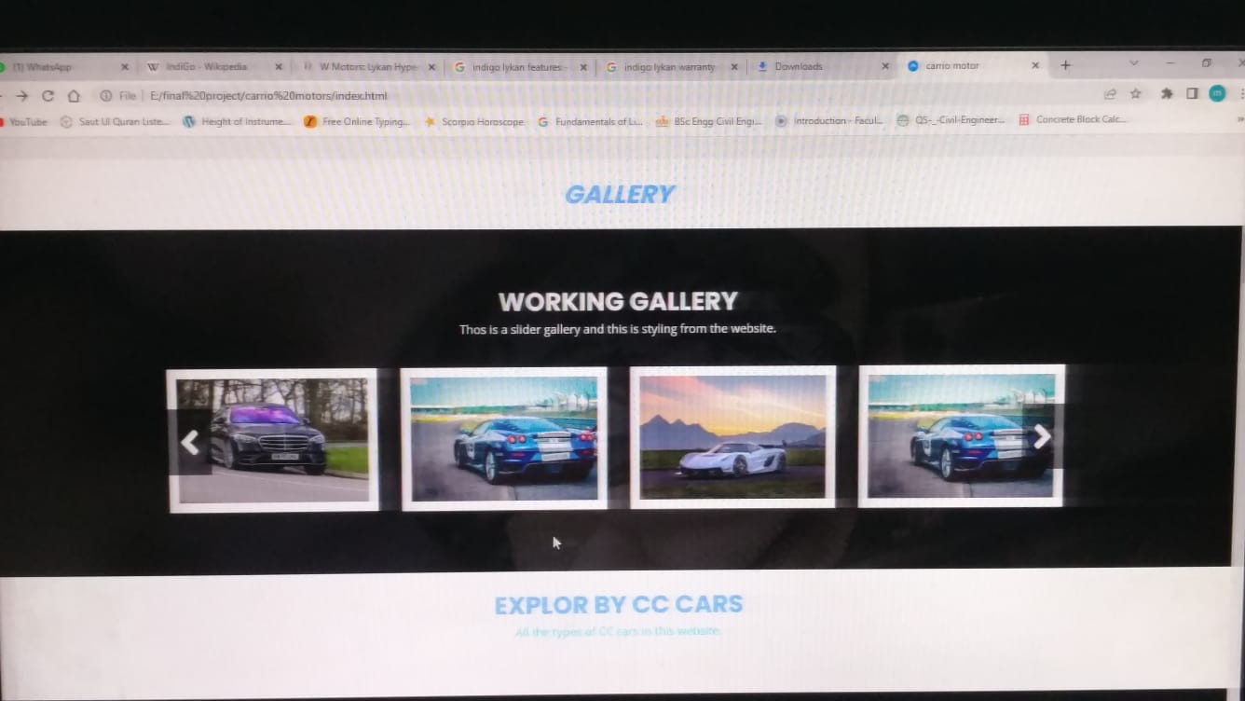

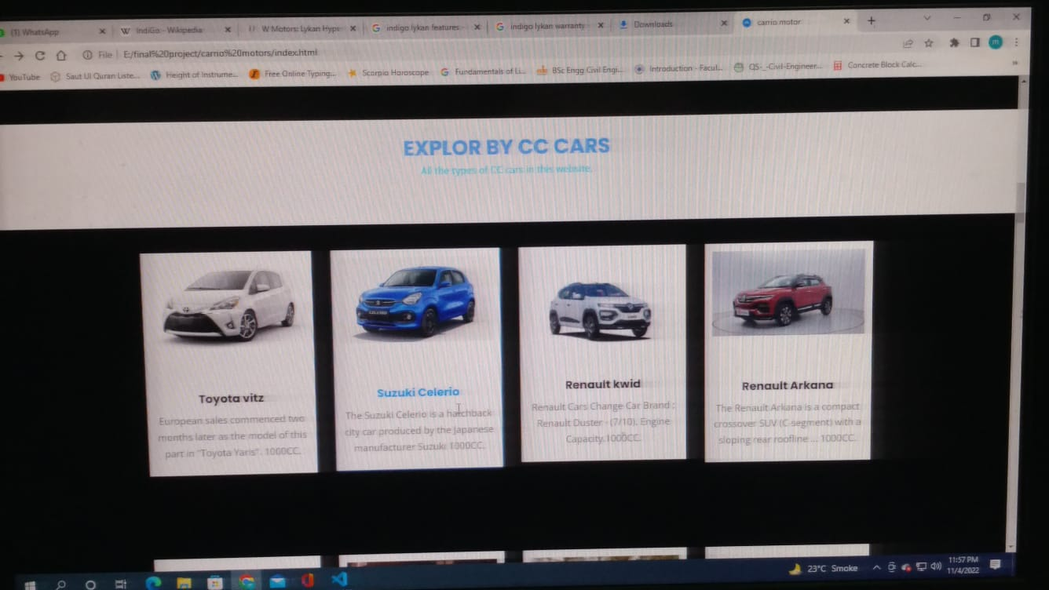

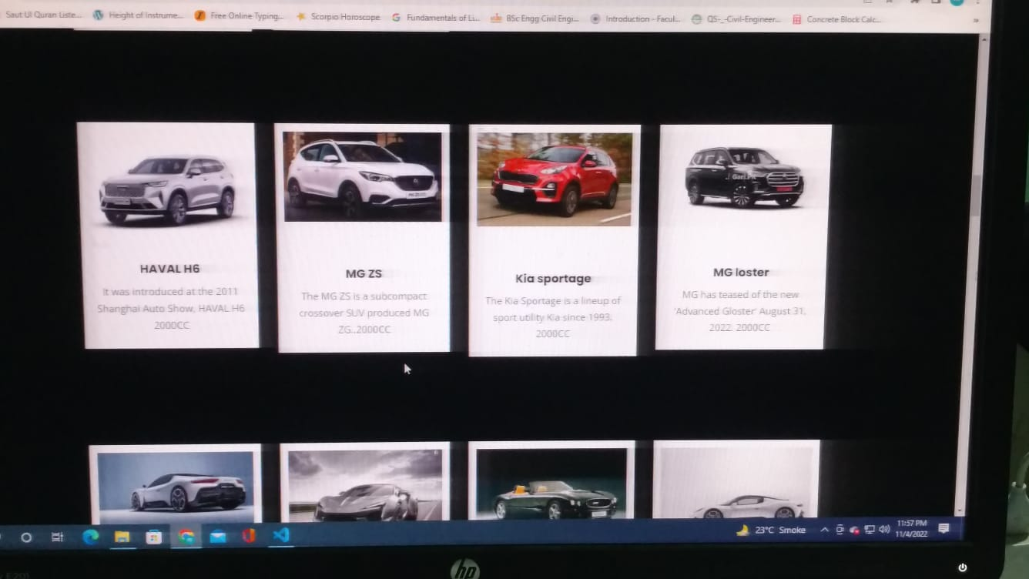

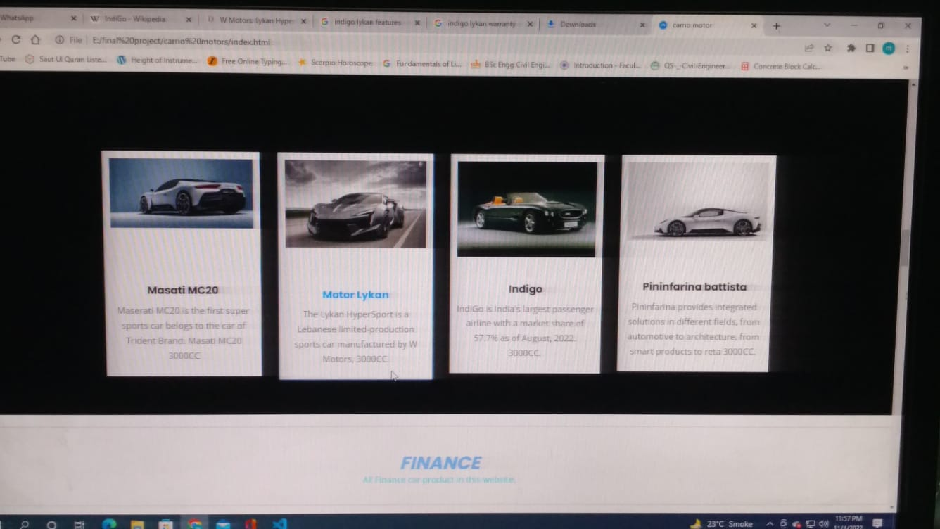

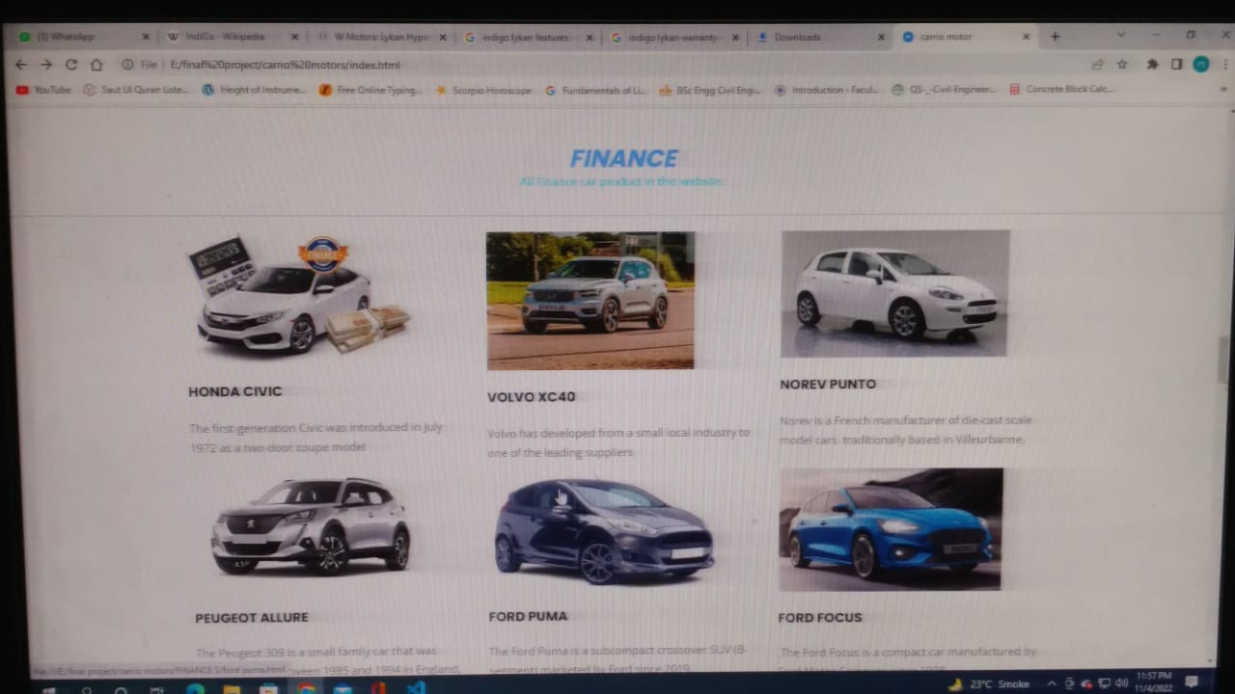

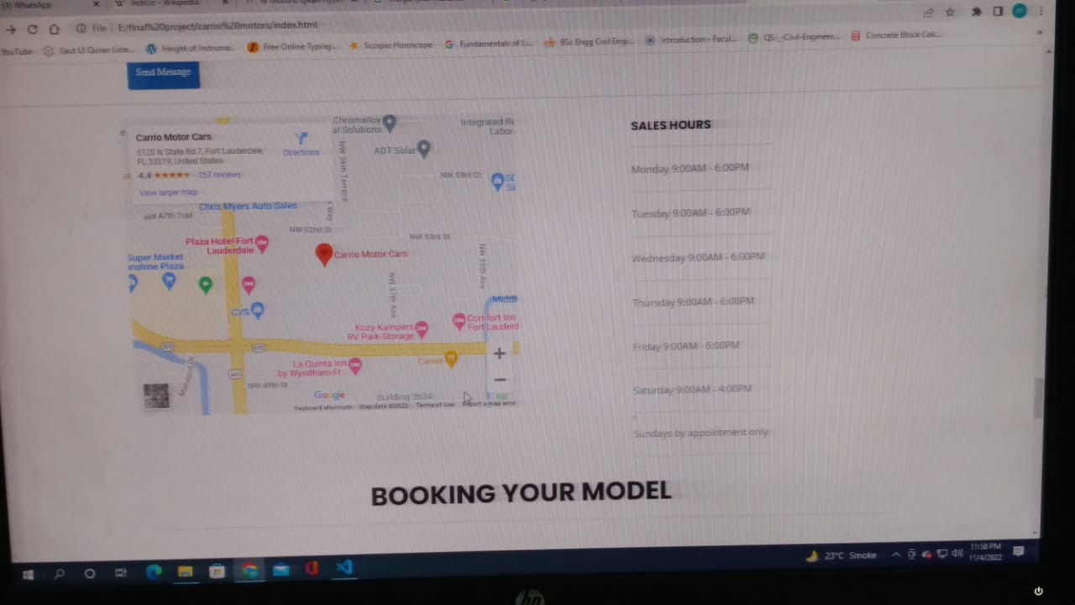

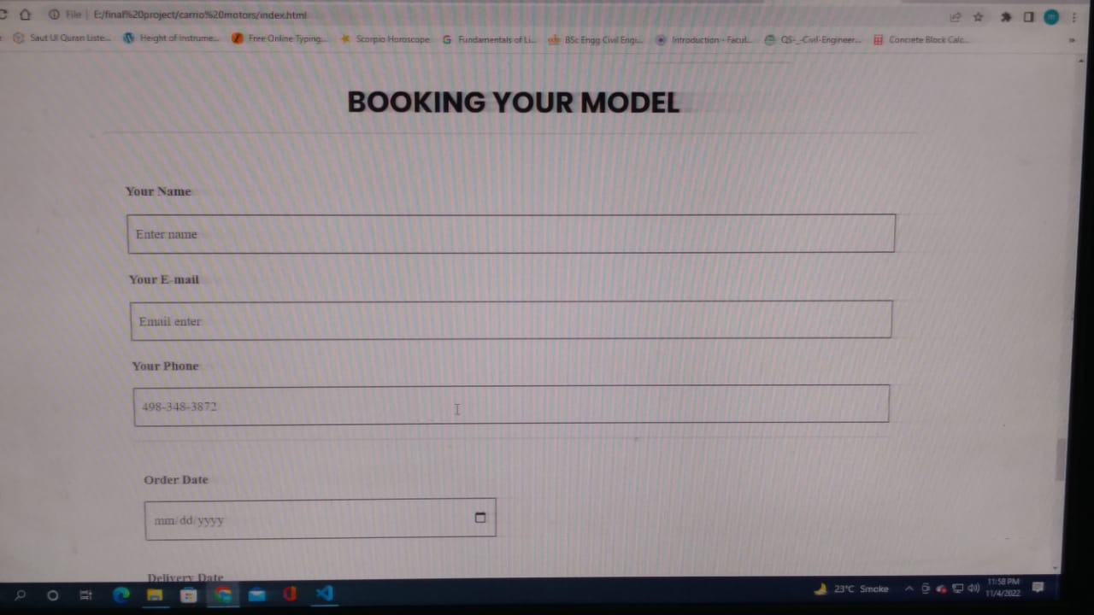



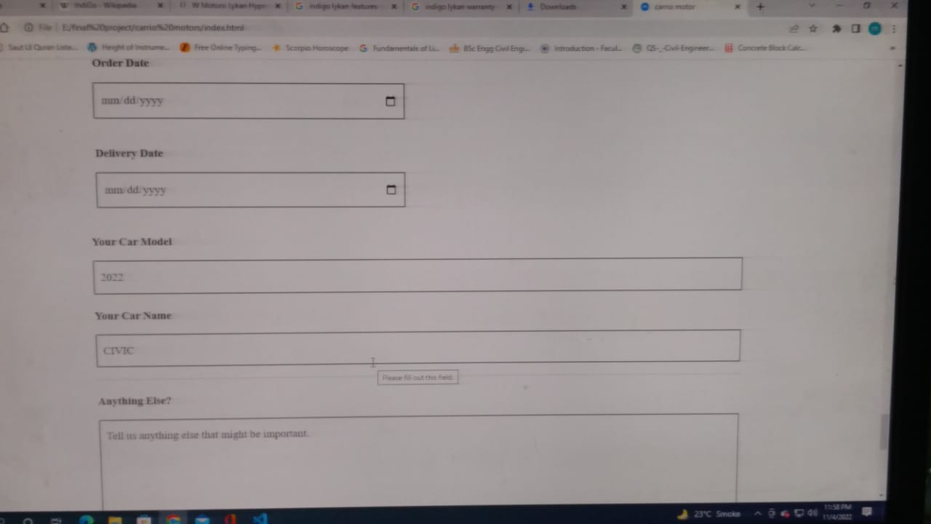

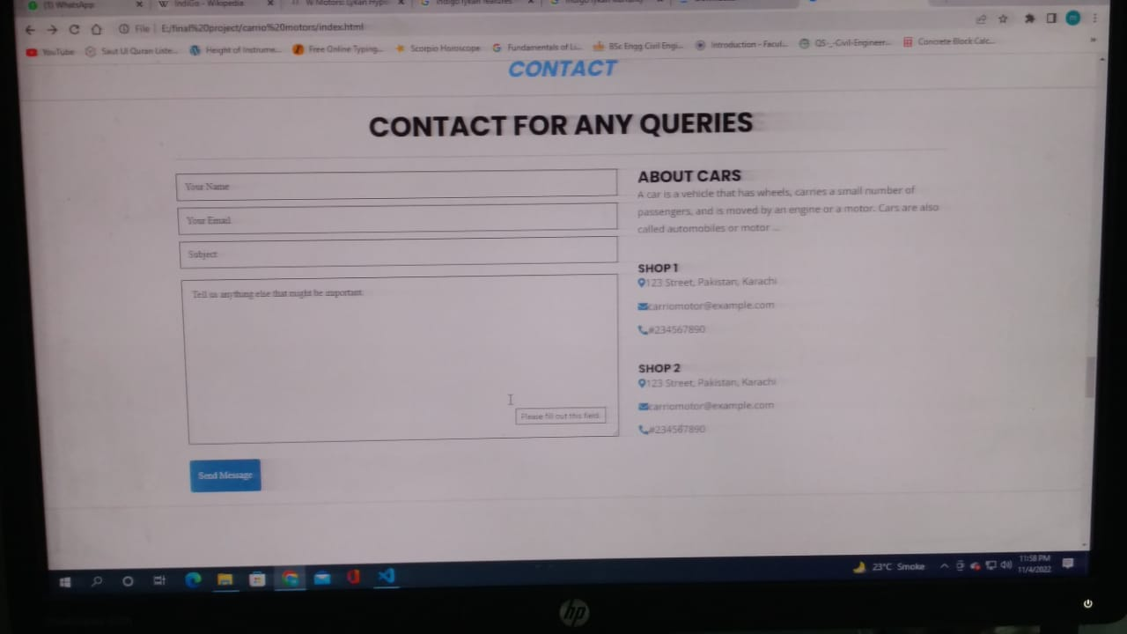

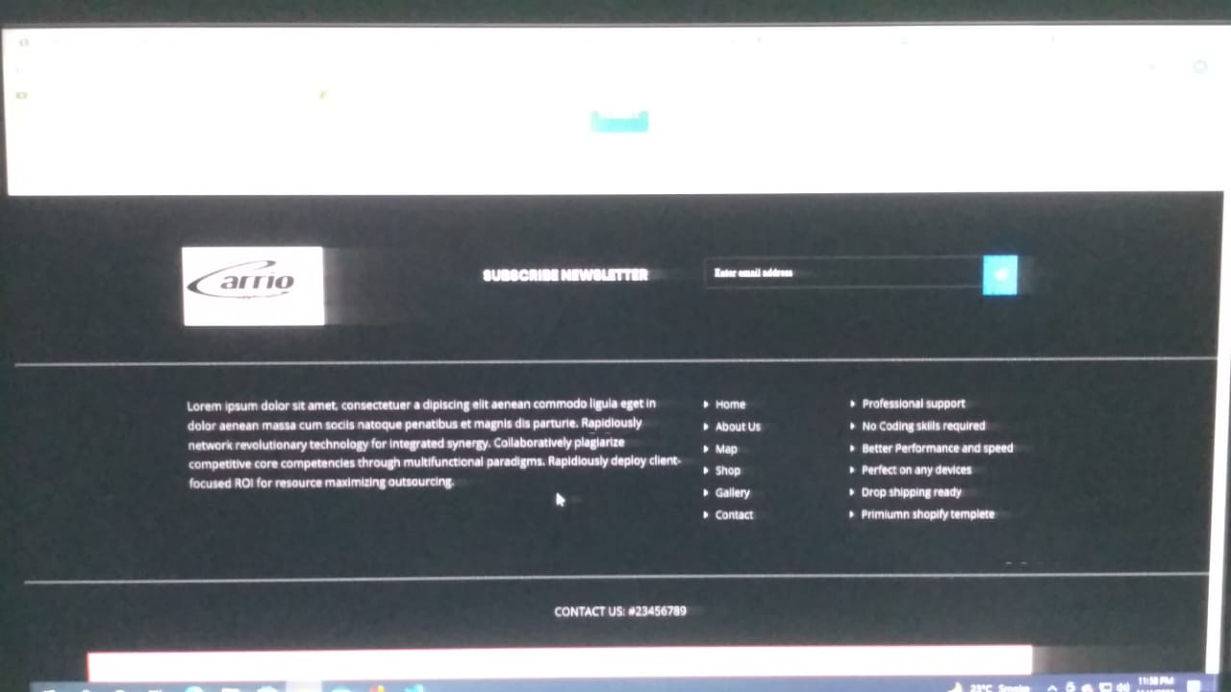

# Thank You For Reading The Documentation.

Please Follow The Instructions Above !!